**A**

**PROJECT REPORT**

**ON**

**TASK MANAGEMENT SYSTEM**

**FOR**

**CREAZIONE SOFTWARE**

**IN PARTIAL FULFILLMENT OF**

**MASTER OF COMPUTER APPLICATION**

**BY**

**NAMDEV RAVSAHEB KSHIRSAGAR**

**MCA – III SEM -VI**

**2018-2019**

**SUBMITTED**

**SAVITRIBAI PHULE PUNE UNIVERSITY**

**SINHGAD INSTITUTE OF MANAGEMENT**

**PUNE-411 041.**

**CERTIFICATE**

This is to certify that Mr. **Namdev Ravsaheb Kshirsagar** has successfully completed his project work entitled **“Task Management System”** in partial fulfillment of MCA program for the year 2018-2019. He / She have worked under our guidance and direction.

**Prof. Aparna kulkarni Dr. Chandrani Singh**

**(Project Guide) ( Director SIOM - MCA)**

**Examiner 1 Examiner 2**

**Date :**

**Place :**

**INDEX**

|  |  |  |
| --- | --- | --- |
| Sr. No. | Title | Page No. |
| **1** | **CHAPTER 1 : INTRODUCTION** | 1 |
|  | 1.1 Company Profile | 2 |
|  | 1.2 Existing System and Need for System | 4 |
|  | 1.3Scope of Work | 5 |
|  | 1.4 Operating Environment – Hardware and Software | 6 |
|  | 1.5 Detail Description of Technology | 7 |
| **2** | **CHAPTER 2: PROPOSED SYSTEM** | 10 |
|  | 2.1Proposed System | 11 |
|  | 2.2 Objectives of System | 12 |
|  | 2.3 User Requirement | 13 |
|  | 2.4 Module Specification | 14 |
| **3** | **CHAPTER 3: REQUIREMENT DETERMINATION & ANALYSIS** | 15 |
|  | 3.1 Fact Finding Technique | 16 |
|  | 3.2 Feasibility Study | 20 |
| **4** | **CHAPTER 4 :ANALYSIS & DESIGN** | 22 |
|  | 4.1 Use Case Diagram | 23 |
|  | 4.2 Activity Diagram | 30 |
|  | 4.3 Sequence Diagram | 47 |
|  | 4.4 Class Diagram | 51 |
|  | 4.5 Entity relationship diagram | 52 |
|  | 4.6 Component Diagram | 53 |
|  | 4.7 Deployment Diagram | 54 |
|  | 4.8 User Interface Design(Screen Shot) | 55 |
|  | 4.9 Table Specification | 75 |
|  | 4.10 Data Dictionary | 83 |
|  | 4.11 Test Procedure and Implementation | 88 |
| **5** | **CHAPTER 5 : USER MANUAL** | 95 |
|  | 5.1 Login | 85 |
|  | 5.2 User registration | 86 |
| 6 | Drawbacks and Limitations | 103 |
| 7 | Proposed Enhancements | 104 |
| 8 | Conclusions | 105 |
| 9 | Bibliography | 106 |
| 10 | **ANNEXURES :** | 107 |
|  | **ANNEXURE 1 : USER INTERFACE & INPUT SCREENS** | 108 |
|  | **ANNEXURE 2 : OUTPUT REPORTS WITH DATA** | 117 |
|  | **ANNEXURE 3 : SAMPLE PROGRAM CODE** | 122 |

**CHAPTER 1**

**INTRODUCTION**

**1.1 COMPANY PROFILE**

**CREAZIONE SOFTWARE** isa software company established in 2013. Services provided by CREAZIONE SOFTWAREare.

**1) WEBSITE SITE DESIGNING**:- Web designing plays vital role in attracting customers to your sites. We develop such brilliant web-sites with latest technology that will help you to run your business more successfully.

**2) WEB DEVELOPMENT:-** We have passionate team to design and most secured website’s according to customers need. With Code Guard customers can make there website secure as well as take the back up on time to time.

**3) ANDROID DEVELOPMENT:-** Creazione develops the best android application,loaded with user friendly features,to boost your business with latest niche technology.

**4) SOFTWARE DEVELOPMENT**:- With our enriching solutions & domain expertise, we design new softwares and enterprise systems for our clients. We follow latest technology and frameworks that make our products more reliable and unique.

Contact Details: Creazione Software

Banglow No.3, Girzar Colony, Near Paud Phata,

Behind Karishma Society, Kothrud,

Kothrud, Pune, Maharashtra 411038

Website: [www.creazionesoftware.com](http://www.creazionesoftware.com)

E-mail: contact@creazionesoftware.com

**1.2** **Existing System And Need For System.**

**Existing System**

* **Time Consuming:** There are tons of things that need to manage for the Managers and Employee if they are doing that manually, and that’s why in our case the same thing was wasting a hell lot of a time.

Interested peoples always had to waste the valuable time of their own and of office Manager too, because everything was get managed manually. Also to make payments there was no online transaction facility was available before so employee always have to make payments via cash or cheque which was risky in some cases and even time consuming for users.

**Need of System**

* The system helps users in lot of ways. It reduces the paper work and helps to keep the records of all the Manager and Employee and also helps to keep department wise of activities so this is highly needed.
* Maintaining inventory will also become easier if proposed system get used, the main cause is that managing inventory is somewhat complex and even also time consuming task.
* **1.3 Scope of work**
* The “Task Management” for Assign Task and other details.. Today task management people need to do a manual calculations like details.
* The main use of “Task Management” is the Admin or his staff because with this program’s help he will be able to keep a bird’s eye view and necessary attention to his business.
* Total business, Task management, monthly payment etc. Those data is stored on server. Here we are using the Firefox Web Service. Demand calculation about cash collections which is wasting huge time of both sides.
* All such management is time consuming . We are going to automate management in this project .So all management operations will be smoother than before which will increase accuracy.
* The productivity of employee & management, Also it will help to management to track the summary & growth on the click of system Online task Assign System is bound to increase as it.
* Saves a lot of time.Online task system instantly enhances the Business And Others Department of related shop .It also allows customers to customize their Assign.

**1.4 .Operating Environment –Hardware and Software**

**Software Specification:-**

OS : Windows XP or advanced

Front End :HTML,CSS,JSP,Apache,tomcat,Java

Back End : MySQL 5.0

Web Browser : Chrome/Mozilla/ Firefox /Internet Explorer

**Hardware Specification:-**

Processor : Pentium4 Processor 2.80GHz

RAM : 2.00GB

HDD : 40 GB or Above

**1.5. Detail Description of Technology Used.**

**HTML -** Hypertext Markup Language (HTML) is the standard markup language for creating web pagess and web applications With Cascading Style sheet (CSS) and JavaScript it forms a triad of cornerstone technologies for the World Wide Web.

Web browsers receive HTML documents from a web server or from local storage and render the documents into multimedia web pages. HTML describes the structure of a web page semantically and originally included cues for the appearance of the document.

**CSS-**

Cascading Style Sheets, fondly referred to as CSS, is a simple design language intended to simplify the process of making web pages presentable.CSS handles the look and feel part of a web page. Using CSS, you can control the color of the text, the style of fonts, the spacing between paragraphs, how columns are sized and laid out, what background images or colors are used, layout designs,variations in display for different devices and screen sizes as well as a variety of other effects.

**JSP-**

Java Server Page (JSP) is a technology for controlling the content or appearance of Web pages through the use of servlets, small programs that are specified in the Web page and run on the Web server to modify the Web page before it is sent to the user who requested it. Sun Microsystems, the developer of Java, also refers to the JSP technology as the Servlet application program interface (API). An HTML page that contains a link to a Java servlet is sometimes given the file name suffix of .JSP.

**APACHE TOMCAT: Apache Tomcat**, often referred to as **Tomcat Server**, is an open-source Java Servlet Container developed by the Apache Software Foundation (ASF). Tomcat implements several Java EE specifications including Java Servlet, JavaServer Pages (JSP), Java EL, and WebSocket, and provides a "pure Java" HTTP web server environment in which Java code can run.

Tomcat is developed and maintained by an open community of developers under the auspices of the Apache Software Foundation, released under the Apache License 2.0 license, and is open-source software.

**Java**

Initially the language was called as “oak” but it was renamed as “Java” in 1995. The primary motivation of this language was the need for a platform-independent (i.e., architecture neutral) language that could be used to create software to be embedded in various consumer electronic devices.

**MySQL –**

MySQL is a very powerful program in its own right. It handles a large subset of the functionality of the most expensive and powerful database packages.

**CHAPTER 2:**

**PROPOSED SYSTEM**

**2.1 Proposed system**

* The main purpose of this document is to illustrate the requirement of the project the “Task Management” .The purpose of this project is to provide a

friendly environment to maintain the task Assign to employee.

* Platform that offers flexible, reliable ,scalable, easy-to-use, and cost-effective solutions. It is easy to use, more attractive compare to Mannual system.

1. It is safe and secure to make online payments.
2. It is fast and accurate.
3. It takes less space to store data.
4. It requires less paper work.
5. Searching, retrieve is more accurate and time saving.

**2.2 Objective of the System:-**

* To overcome problems faced in manual system.
* To generate error free reports.
* Systematic maintenance of records replacing several registers.
* To reduce the paper work of manager
* To maintain large amount of data.
* Easy to use and efficient computerized system.

**2.3 User Requirements:-**

**Functional Requirements:**

* Admin authentication using user id and password.
* For adding/updating information link button should be there.
* The complete database resides in Server.

**Non-functional Requirements**

* 24 X 7 availability.
* Better component design to get better performance.
* Flexible service based architecture will be highly desirable for future extension.
* Ease of Use-flexibility, performance.
* Security- Privacy, Confidentiality, Integrity, Authentication.
* Comprehensiveness- Transferability, Divisibility, Standardization.
* Maintenance.

**2.4 Module Specification:**

**1.Admin:**

1.Add new business/view/del/update

2.Add manager & assign to business

3.Allocate task to manager as per business

4.pending manager wise & Businesswise

5.set task priority

6.generate the report businesswise task

And employee wise task

**2.Business Manager:**

1. Login

2. New task allocated by admin self

3 Create subtask

4. Assign subtask to employee

5. pending task employee wise

6. pending task date wise

7. Set task priority

8. generate employee performance chart

9 .Submit task to Admin

**3.Employee:**

1.Registration

2.View task by manager

3.submit task with description to manage

4.send to response message

**CHAPTER 4**

**ANALYSIS & DESIGN**

**4.1 USE CASE DIAGRAM:**

**Task Management System Diagram:**

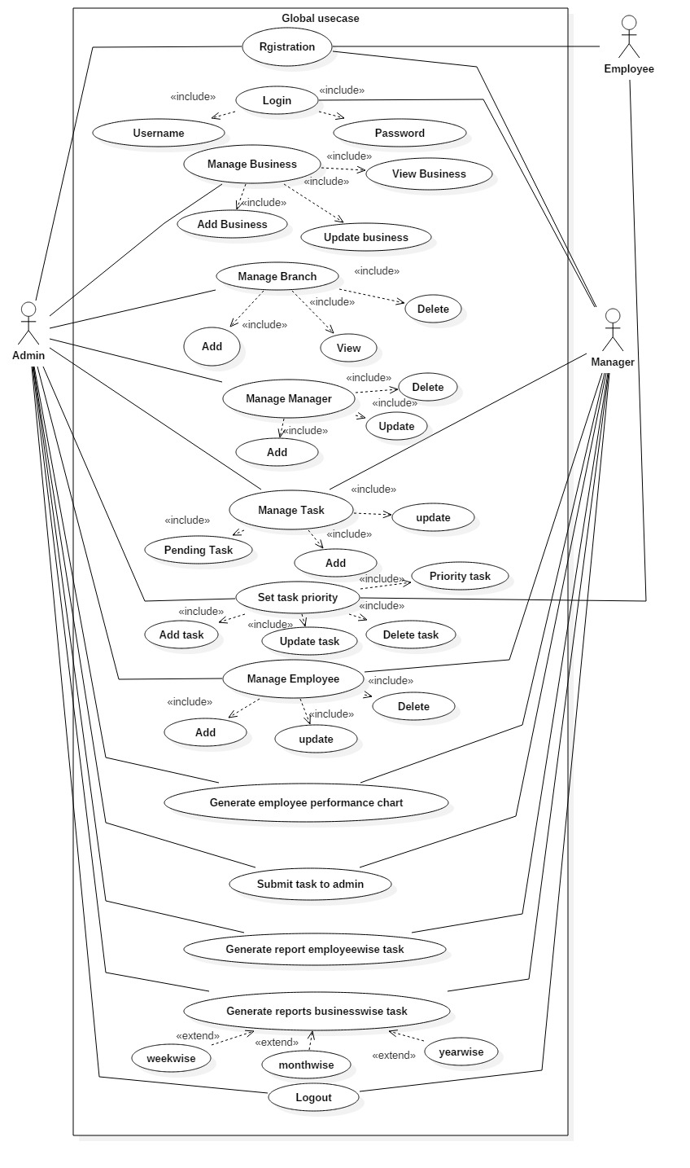

**4.1.2.Admin Management Module**

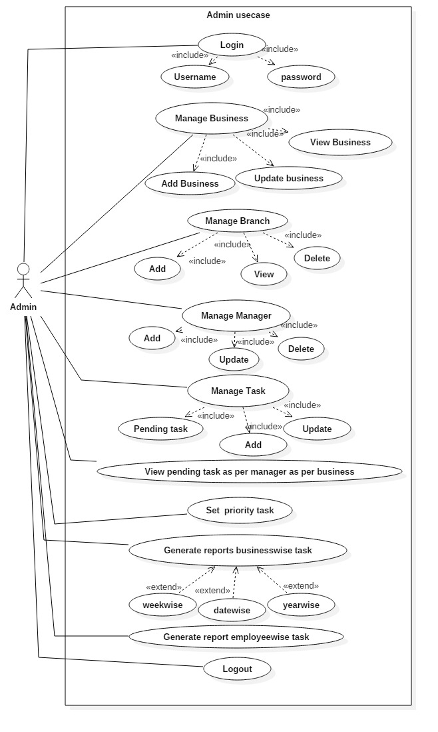

**Use Case Description**

**1) Use Case : Admin Management Module**

**Summary :** In this scenario the admin will manage the all business records assign task to manager .

**Actors :** The actors involved in this process are :-

Primary Actor : Admin

**Precondition :** Admin have to login with valid login credentials.

**Detail Description :** The Admin will upload the task for manager task complete report of manager and it will display to task assign date to complete date.

**Main Flow:** This use case starts when a user wish to add , view,delete.

**Post Condition :** The report submit and will be display to the admin on display sub-module.Data will saved in database

**4.1.3.Manager Management module**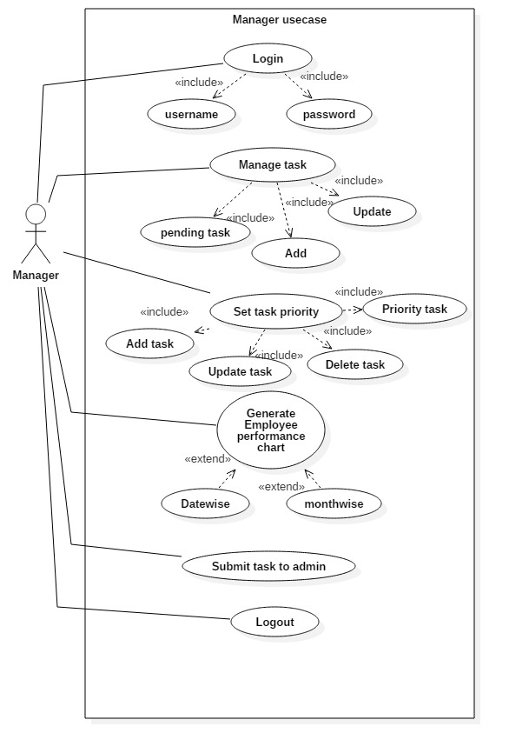

**2)Use Case :** Manager management Module

**Detail description :** In this scenario the manager view task by assigning to the manager .

Manger

**Actor :** The actors involved in this process are :-

Primary Actor : Manager

**Precondition :** Manager have to login with valid login credentials.

**Main Flow**: Manager login first then add employee delete employee

**Description :** The Admin, Manager it is to be add employee and add to task .

**Post Condition :** The all task details will be saved into the database and will be available for doing other operations on dashboard.

**4.1.4.Employee Management Module**



**3)Use Case :** Employee Management Module

**Detail description :** In this scenario the Admin will manage employee in Result module.

**Actors :** The Actors involved in this process are :-

Primary Actor : Admin

**Precondition :** Admin have to login with valid login credentials.

**Description :** The Admin will add result of employee after every task .

**Main Flow:** This module it is to daily task report to manager.

**Post Condition :** The result details will be saved into the database and available to view for users on website.

**4.5 Entity Relationship diagram**

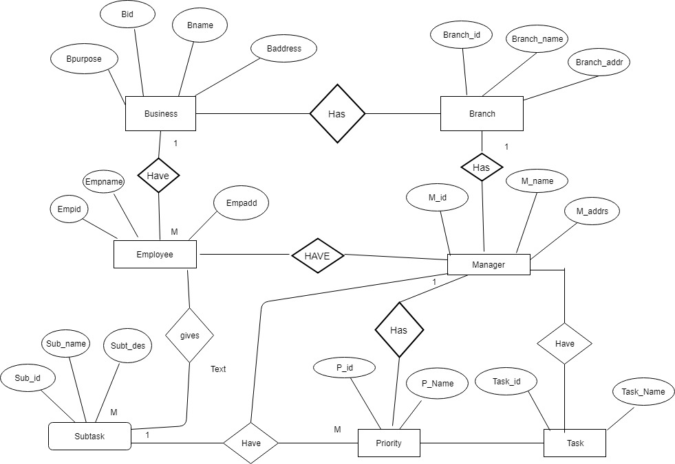

**4.6 Deployment diagram**

**4 .8. TABLE DESIGN:**

**1.Add Business.**

Description :- This table is used to store add business details.

|  |  |  |  |  |
| --- | --- | --- | --- | --- |
| **Fields Name** | **Data Type** | **size** | **Constraints** | **Fields Description** |
| B_id | Int | 10 | Pk | Maintain unique data info |
| B_ name | Varchar | 20 | Not null | Add Business name info |
| B_ Start date | Varchar2 | 20 | Not null | Start date info |
| B_ Licence | Varchar2 | 20 | Not null | Business licence no info |
| B_Purpose | Varchar2 | 20 | Not null | Purpose of business info |
| B_Website | Varchar2 | 20 | Not null | Business website info |

**2.Branch Table**

Description: This table is storing branch details

|  |  |  |  |  |
| --- | --- | --- | --- | --- |
| **Fields Name** | **Data Type** | **size** | **Constraints** | **Description** |
| B _Branch id | Int | 20 | Pk | Business branch id info |
| B_Branch name | Varchar | 30 | Not null | Branch name info |
| B_Branch address | Varchar | 20 | Not null | branch Address info |
| B_Branch sdate | date |  | Not null | Branch s dateinfo |
| B_Branch open time | date |  | Not null | Branch open time info |
| B_Branch close time | date |  | Not null | Business close time info |
| B_Bid | int | 20 | fk | Business id info |

**3.Manager Table**

|  |  |  |  |  |
| --- | --- | --- | --- | --- |
| **Field_Name** | **Data type** | **size** | **Constraints** | **Description** |
| M_id | Int | 20 | Pk | Manager_id info |
| M_ name | Varchar | 40 | Not null | Manager name info |
| M _address | Varchar | 40 | Not null | Manager address info |
| M_contact | Varchar | 20 | Not null | Manager contact info |
| M_Email | Varchar | 20 | Not null | Manager email info |
| M_Username | Varchar | 20 | Not null | Manager username info |
| M_Password | Varchar | 20 | Not null | Manager password info |
| M_AadharNo | Varchar | 20 | Not null | Manager aadhar no info |
| M_Qualification | Varchar | 20 | Not null | Manager qualification info |
| M_Experiance | Varchar | 20 | Not null | Manager experience i |
| M_BranchId | int | 10 | Fk | Branch id info |

**4.Task Table**

|  |  |  |  |  |
| --- | --- | --- | --- | --- |
| **Fields Name** | **Data Type** | **size** | **Constraints** | **Description** |
| Task _id | Int | 20 | Primary key autoincreament | Task id info |
| Task _name | Varchar | 40 | Not null | Task name info |
| Task_ Desc | Varchar | 50 | Not null | Task desc info |
| Task_ ADate | date |  | Not null | Task assign date |
| Task _EDate | date |  | Not null | Task end date |
| Task_Status | Varchar | 30 | Not null | Status info |
| Mid | Int | 15 | Fk | Manager id info |

**5.Update task Table**

|  |  |  |  |  |
| --- | --- | --- | --- | --- |
| **Fields Name** | **Type** | **size** | **Constraint** | **Description** |
| Update _task name | varchar | 40 | Pk | Update task info |
| Update _task date | varchar | 40 | NotNull | Update task date info |

**6.Submit Task**

|  |  |  |  |  |
| --- | --- | --- | --- | --- |
| **Fields Name** | **Type** | **size** | **Constraint** | **Description** |
| Sub _id | Int | 10 | Pk | Sumbit task id info |
| Sub _Tname | Varchar | varchar | Not null | Submit task name |
| Task_ Desc | Varchar | varchar | Not null | Task description info |
| Task _Adate | Varchar | date | Not null | Task assign date |
| Task _EDate | Varchar | date | Not null | Submit Task ending date |
| Task_ Status | Varchar | 40 | Not null | Submit task date |

**7.Employee Table**

|  |  |  |  |  |
| --- | --- | --- | --- | --- |
| **Fields Name** | **Type** | **size** | **Constraint** | **Description** |
| Emp_id | Int | 10 | Pk | Emp _id details |
| Emp_ Address | Varchar | 20 | Not null | Emp address details |
| Emp _contact | Varchar | 20 | Not null | Emp contact details |
| Emp_Gender | Varchar | 10 | Not null | Emp gender info |
| Emp_Username | Varchar | 20 | Not null | Emp user name info |
| Emp_Password | Varchar | 20 | Not null | Emp password |
| Emp_Qualification | Varchar | 20 | Not null | Emp qualification |
| Emp _branchId | Int | 10 | Fk | Branch id info |

**8.Manager Add Task Table**

|  |  |  |  |  |
| --- | --- | --- | --- | --- |
| **Fields Name** | **DataType** | **size** | **Constraint** | **Description** |
| M_add task | varchar | 40 | Primary key | Manager_add task info |
| M_task description | varchar | 20 | Not Null | Manager task info |
| M_task Adate | date |  | Not Null | Task assign date info |
| M_enddate | date |  | Not Nul | End date info |
| M_select business | varchar | 30 | Not Null | Manager select business |
| Select manager | varchar | 20 | Not Null | Select manager info |

**Priority table:**

|  |  |  |  |  |
| --- | --- | --- | --- | --- |
| **Fields Name** | **Data Type** | **size** | **Constraints** | **Description** |
| Pid | Int | 10 | Pk | P_id info |
| priority | Varchar | 20 | Not Null | Priority info |

**Business Many:**

|  |  |  |  |  |
| --- | --- | --- | --- | --- |
| **Fields Name** | **DataType** | **size** | **Constraint** | **Description** |
| bid | Int | 10 | Fk | B_id info |
| BranchId | Int | 20 | Fk | Branch info |
| EmpId | Int | 120 | Fk | Emp_id info |
| TaskId | Int | 20 | Fk | Task_id info |

**4.9 Data Dictionary**

|  |  |  |  |  |  |  |
| --- | --- | --- | --- | --- | --- | --- |
| **Sr.no** | **Fields Name** | **DataType** | **size** | **Constraint** | **Description** | **Table Name** |
| 1 | B_id | Int | 10 | Pk | Maintain unique data info | Add business |
| 2 | B_ name | Varchar | 20 | Not null | Add Business name info | Add business |
| 3 | B_ Start date | Varchar2 | 20 | Not null | Start date info | Add business |
| 4 | B_ Licence | Varchar2 | 20 | Not null | Business licence no info | Add business |
| 5 | B_Purpose | Varchar2 | 20 | Not null | Purpose of business info | Add business |
| 6 | B_Website | Varchar2 | 20 | Not null | Business website info | Add business |
| 7 | B _Branch id | Int | 20 | Pk | Business branch id info | Branch table |
| 8 | B_Branch name | Varchar | 30 | Not null | Branch name info | Branch Table |
| 9 | B_Branch address | Varchar | 20 | Not null | branch Address info | Branch Table |
| 10 | B_Branch sdate | date |  | Not null | Branch s dateinfo | Branch Table |
| 11 | B_Branch open time | date |  | Not null | Branch open time info | Branch Table |
| 12 | B_Branch close time | date |  | Not null | Business close time info | Branch Table |
| 13 | B_Bid | int | 20 | fk | Business id info | Branch Table |
| 14 | M_id | Int | 20 | Pk | Manager_id info | Manager table |
| 15 | M_ name | Varchar | 40 | Not null | Manager name info | Manager table |
| 16 | M _address | Varchar | 40 | Not null | Manager address info | Manager table |
| 17 | M_contact | Varchar | 20 | Not null | Manager contact info | Manager table |
| 18 | M_Email | Varchar | 20 | Not null | Manager email info | Manager table |
| 19 | M_Username | Varchar | 20 | Not null | Manager username info | Manager table |
| 20 | M_Password | Varchar | 20 | Not null | Manager password info | Manager table |
| 21 | M_AadharNo | Varchar | 20 | Not null | Manager aadhar no info | Manager table |
| 22 | M_Qualification | Varchar | 20 | Not null | Manager qualification | Manager table |
| 23 | M_Experiance | Varchar | 20 | Not null | Manager experience i | Manager table |
| 24 | M_BranchId | int | 10 | Fk | Branch id info | Manager table |
| 25 | Task _id | Int | 20 | Primary key autoincreament | Task id info | Task table |
| 26 | Task _name | Varchar | 40 | Not null | Task name info | Task table |
| 27 | Task_ Desc | Varchar | 50 | Not null | Task desc info | Task table |
| 28 | Task_ ADate | date |  | Not null | Task assign date | Task table |
| 29 | Task _EDate | date |  | Not null | Task end date | Task table |
| 30 | Task_Status | Varchar | 30 | Not null | Status info | Task table |
| 31 | Mid | Int | 15 | Fk | Manager id info | Task table |
| 32 | Update _task name | varchar | 40 | Pk | Update task info | Update task |
| 33 | Update _task date | varchar | 40 | NotNull | Update task date info | Update task |
| 34 | Sub _id | Int | 10 | Pk | Sumbit task id info | Submit task |
| 35 | Sub _Tname | Varchar | varchar | Not null | Submit task name | Submit task |
| 36 | Task_ Desc | Varchar | varchar | Not null | Task description info | Submit task |
| 37 | Task _Adate | Varchar | date | Not null | Task assign date | Submit task |
| 38 | Task _EDate | Varchar | date | Not null | Submit Task ending date | Submit task |
| 39 | Task_ Status | Varchar | 40 | Not null | Submit task date | Submit task |
| 40 | Emp_id | Int | 10 | Pk | Emp _id details | Employee table |
| 41 | Emp_ Address | Varchar | 20 | Not null | Emp address details | Employee table |
| 42 | Emp _contact | Varchar | 20 | Not null | Emp contact details | Employee table |
| 43 | Emp_Gender | Varchar | 10 | Not null | Emp gender info | Employee table |
| 44 | Emp_Username | Varchar | 20 | Not null | Emp user name info | Employee table |
| 45 | Emp_Password | Varchar | 20 | Not null | Emp password | Employee table |
| 46 | Emp_Qualification | Varchar | 30 | Not null | Emp qualification | Employee table |
| 47 | Emp _branchId | Int | 10 | Fk | Branch id info | Employee table |
| 48 | M_add task | varchar | 40 | Primary key | Manager_add task info | Manager Add task table |
| 49 | M_task description | varchar | 20 | Not Null | Manager task info | Manager Add task table |
| 50 | M_task Adate | date |  | Not Null | Task assign date info | Manager Add task table |
| 51 | M_enddate | date |  | Not Nul | End date info | Manager Add task table |
| 52 | M_select business | varchar | 30 | Not Null | Manager select business | Manager Add task table |
| 53 | Select manager | varchar | 20 | Not Null | Select manager info | Manager Add task table |

**4.7 User Interface Design**

1. **LOGIN PAGE :**

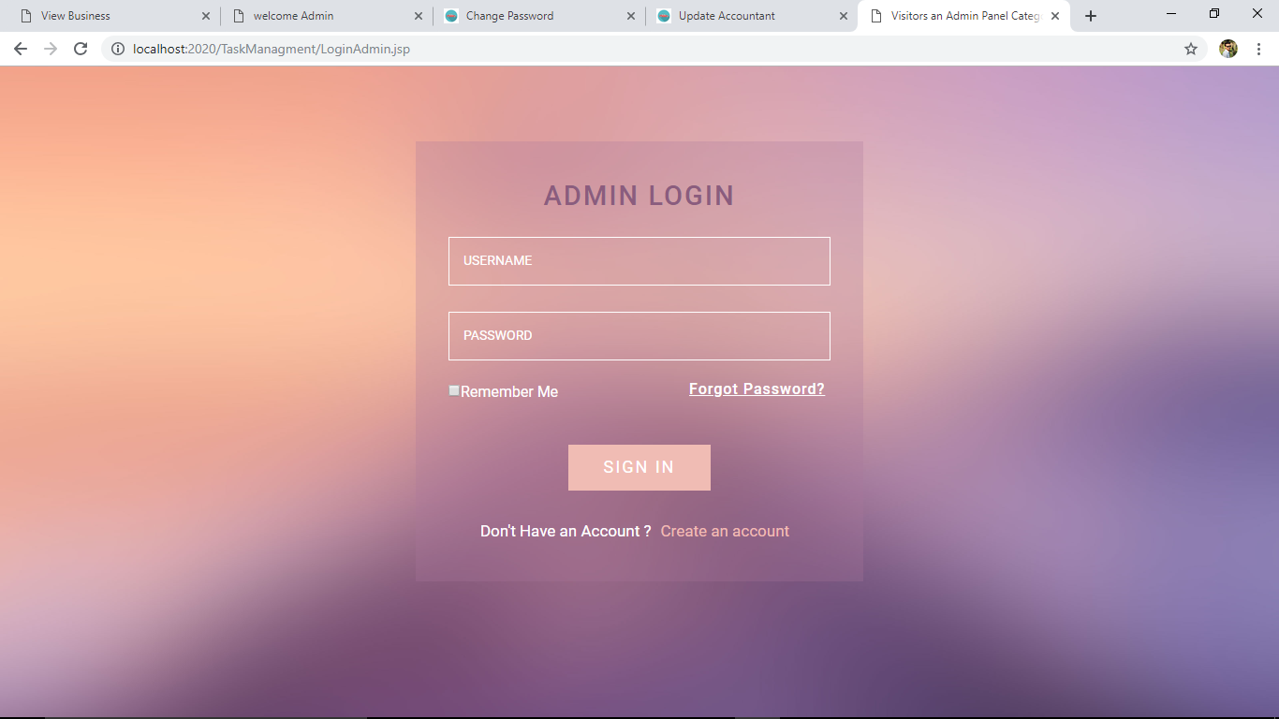

**2 . ADMIN MASTER:**

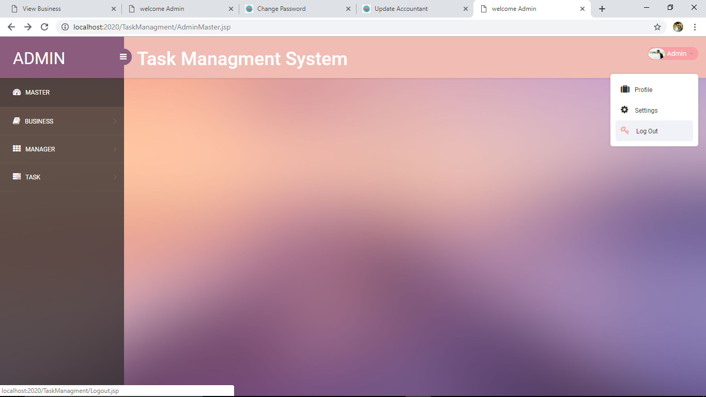

**3.ADD BUSINESS:**

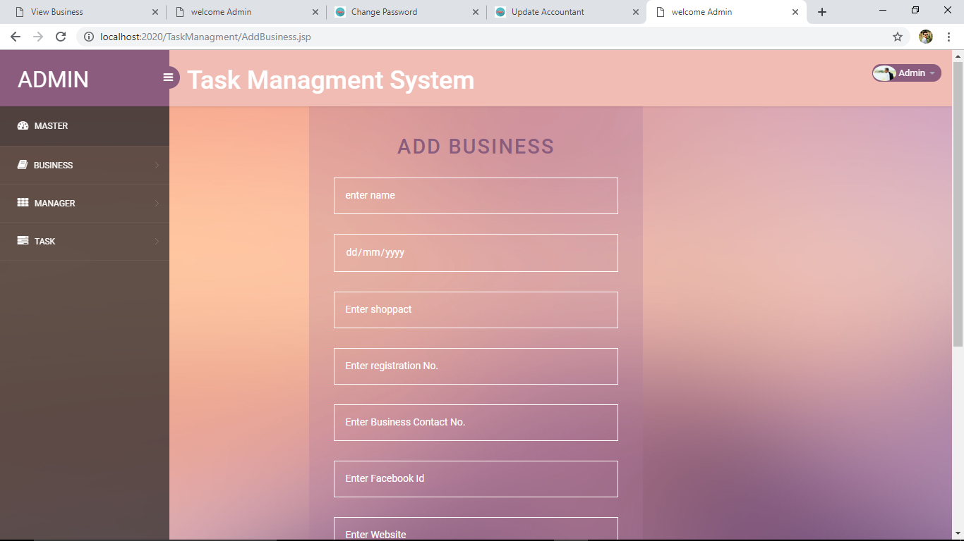

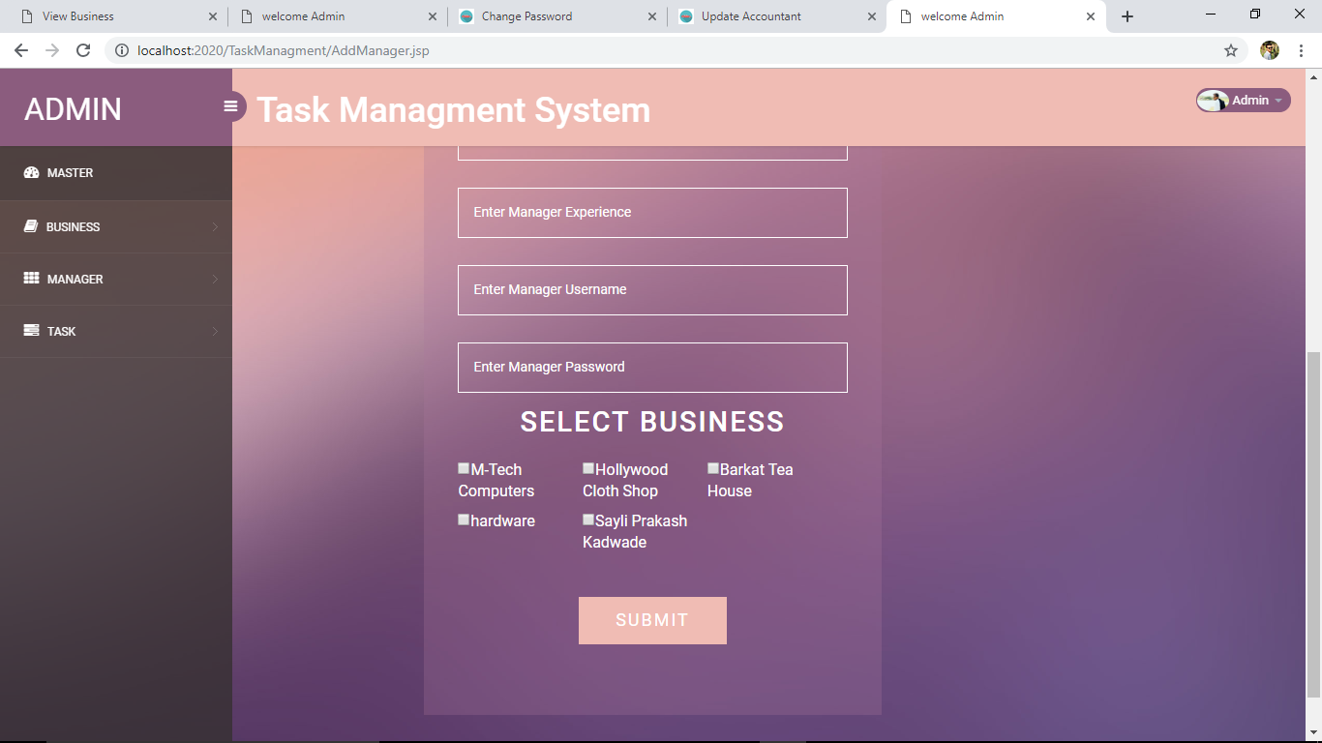

**4 . VIEW BUSINESS RECORDS :**

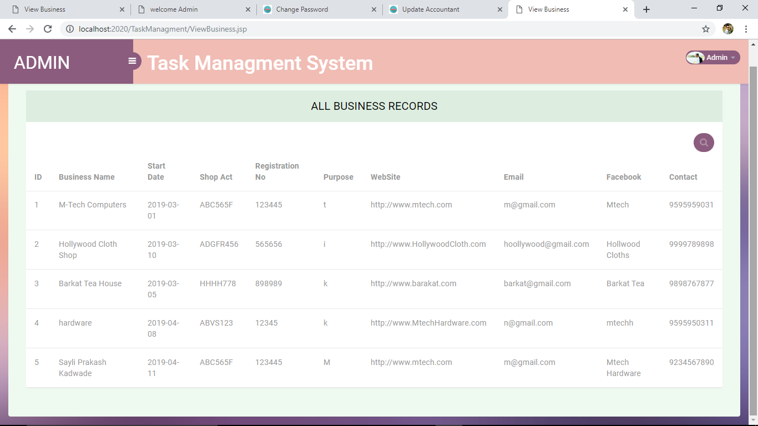

**5 . ADD MANAGER :**

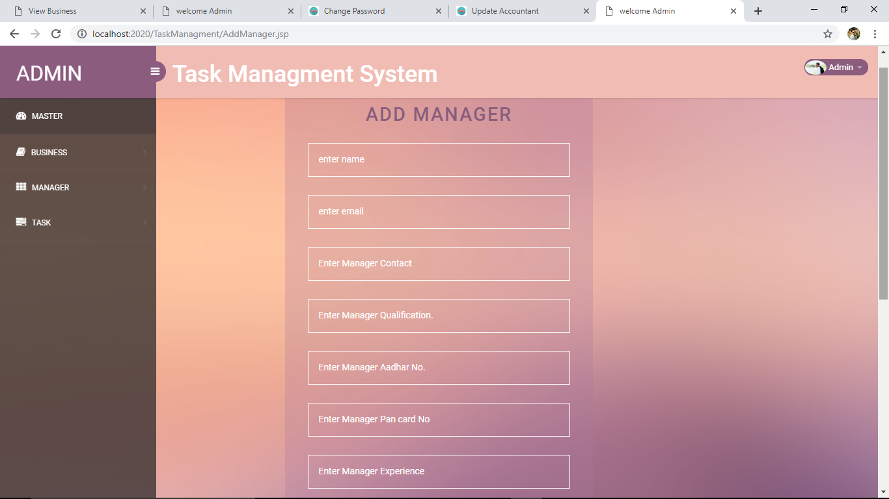

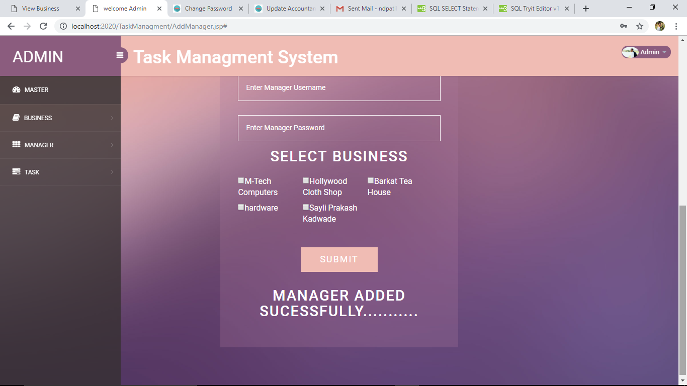

**6 . VIEW MANAGER RECORDS :**

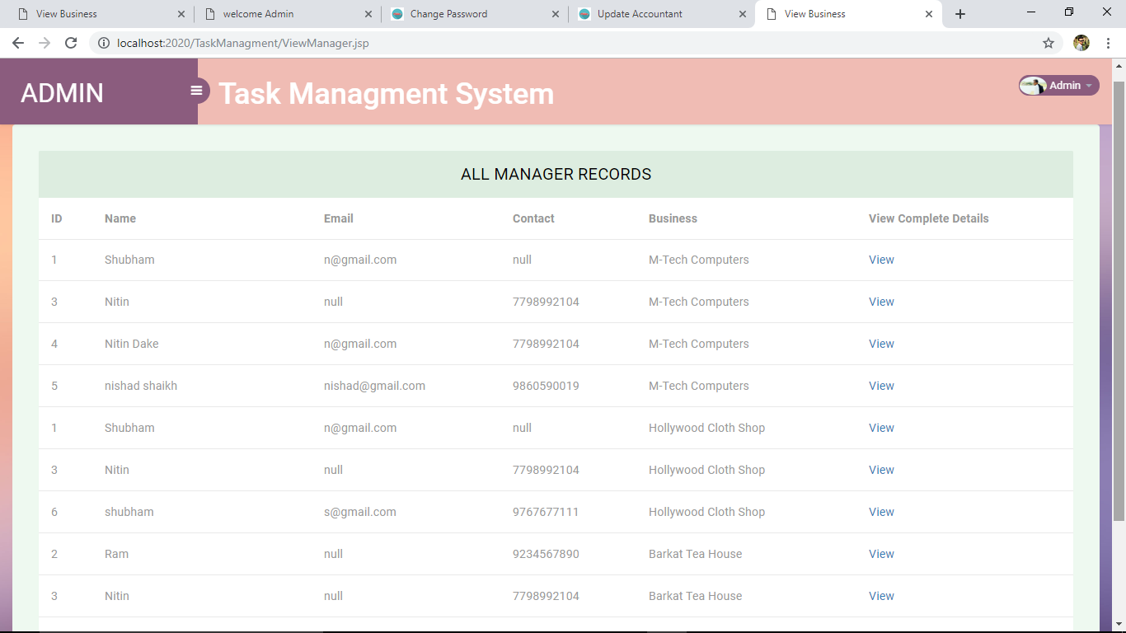

**7 . UPDATE MANAGER :**

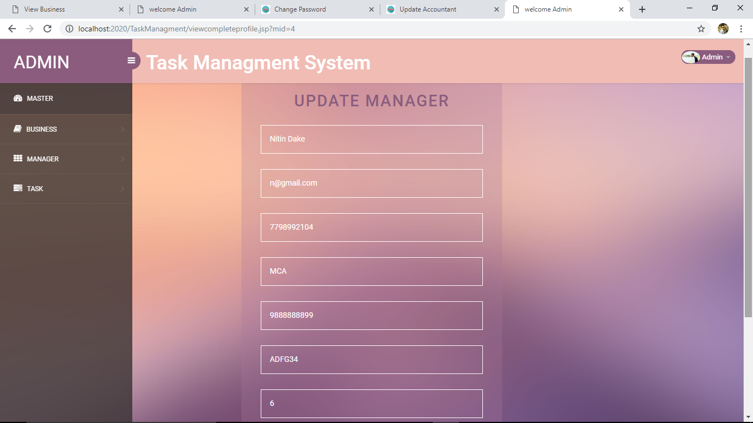

**7.ADD NEW TASK :**

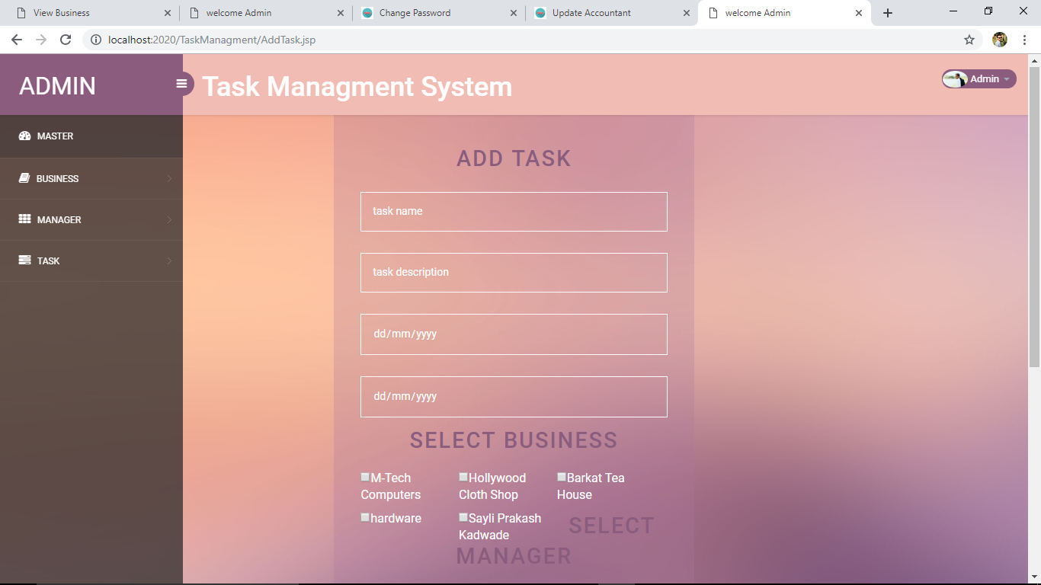

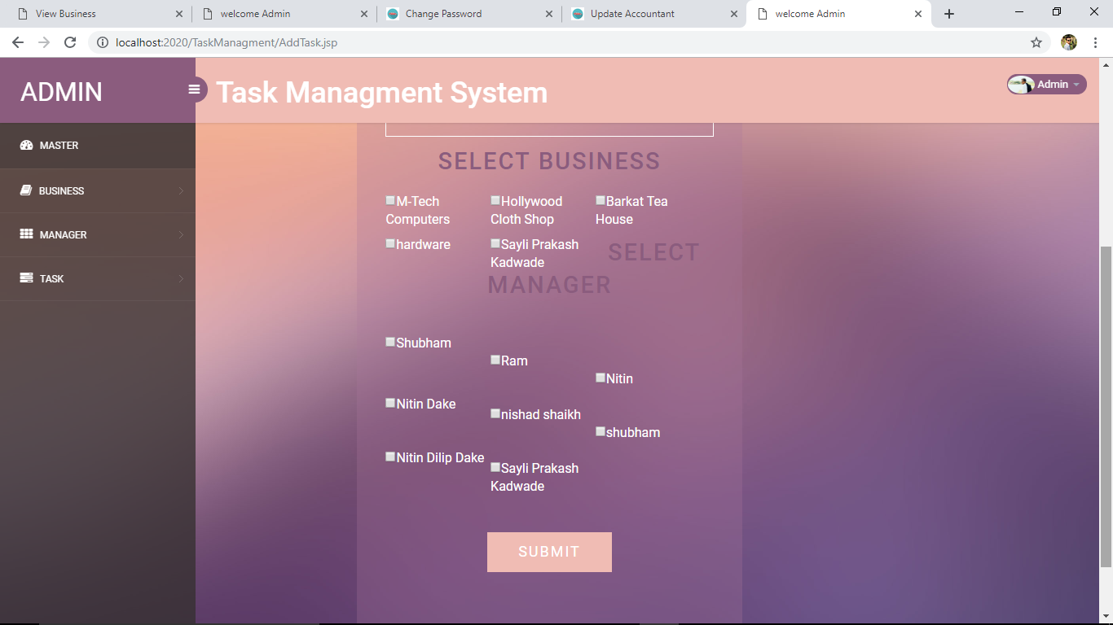

**8 . UPDATE TASK :**

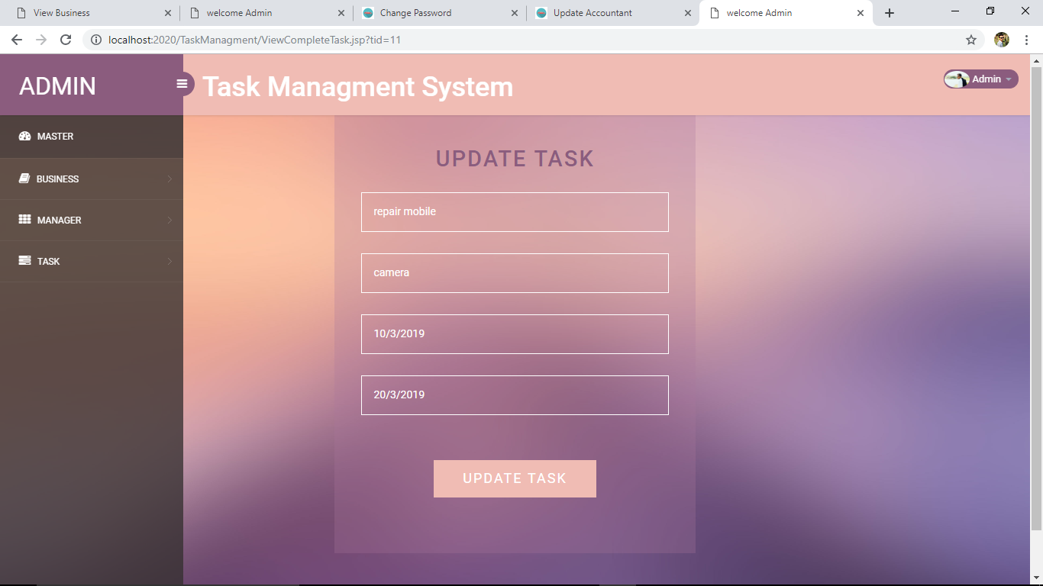

**9 . ALL TASK RECORDS :**

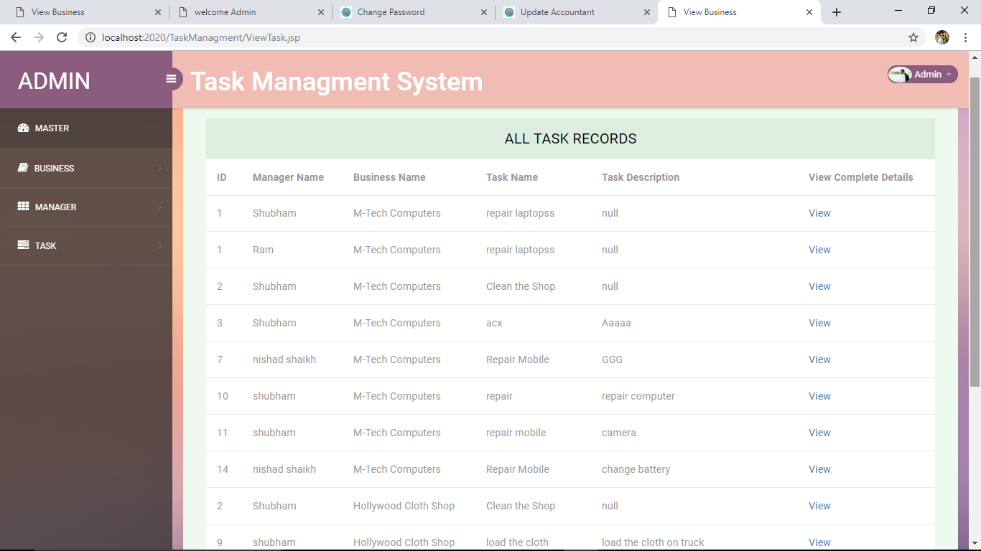

**10.ADMIN LOGOUT:**



**11 . MANAGER LOGIN :**

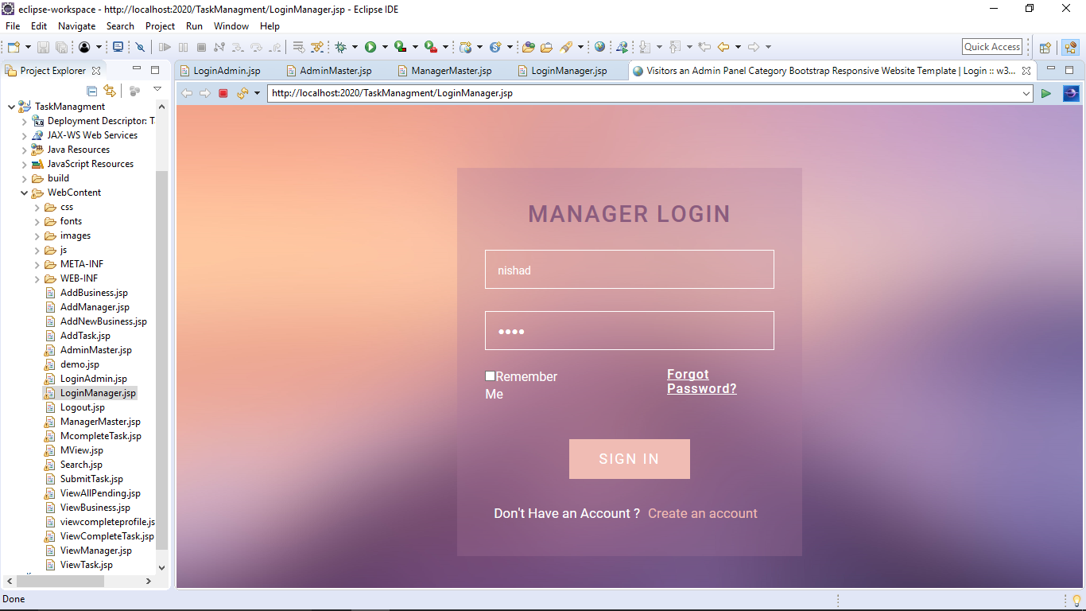

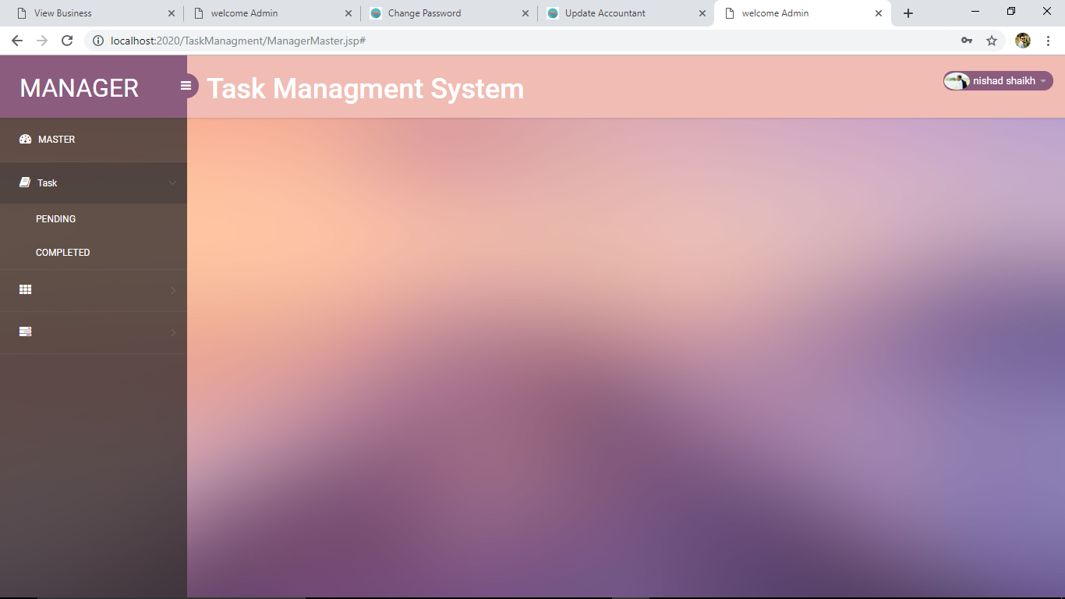

**12.ALL PENDING TASK RECORDS:** 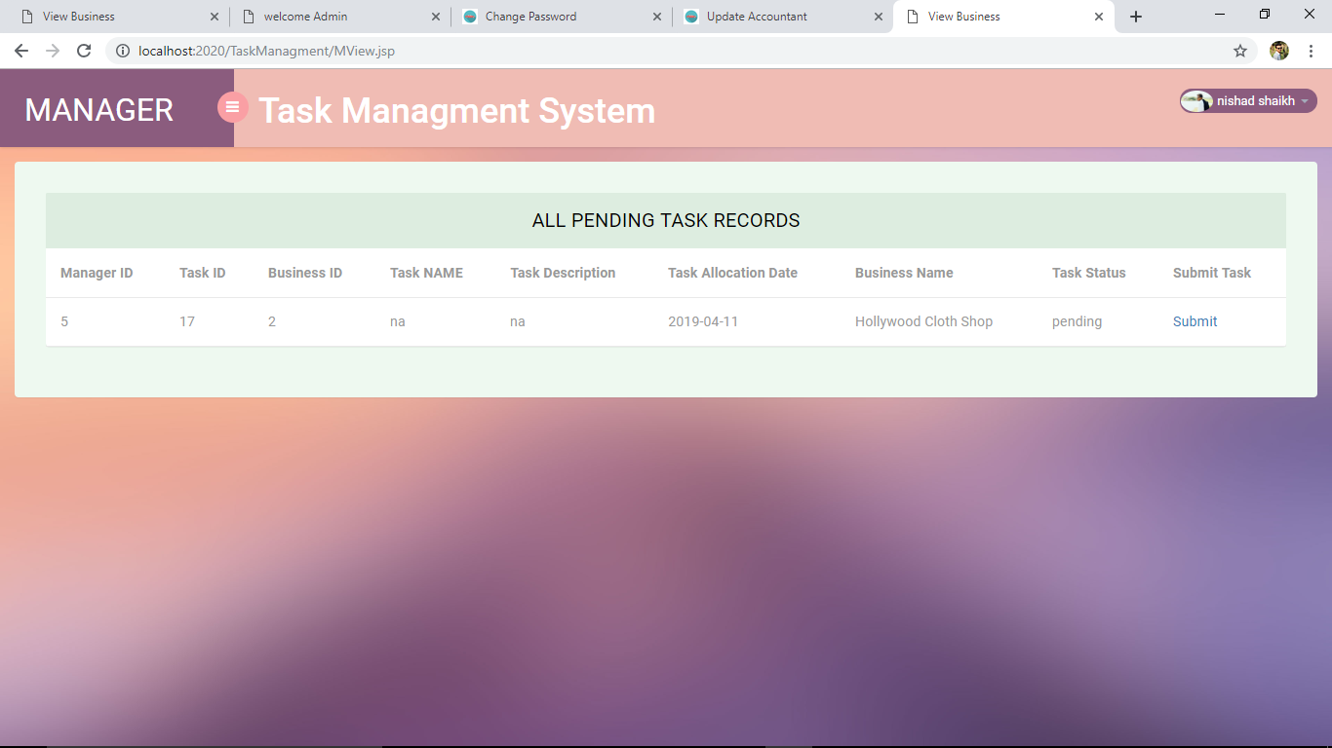

**13.VIEW ALL RECORDS:**

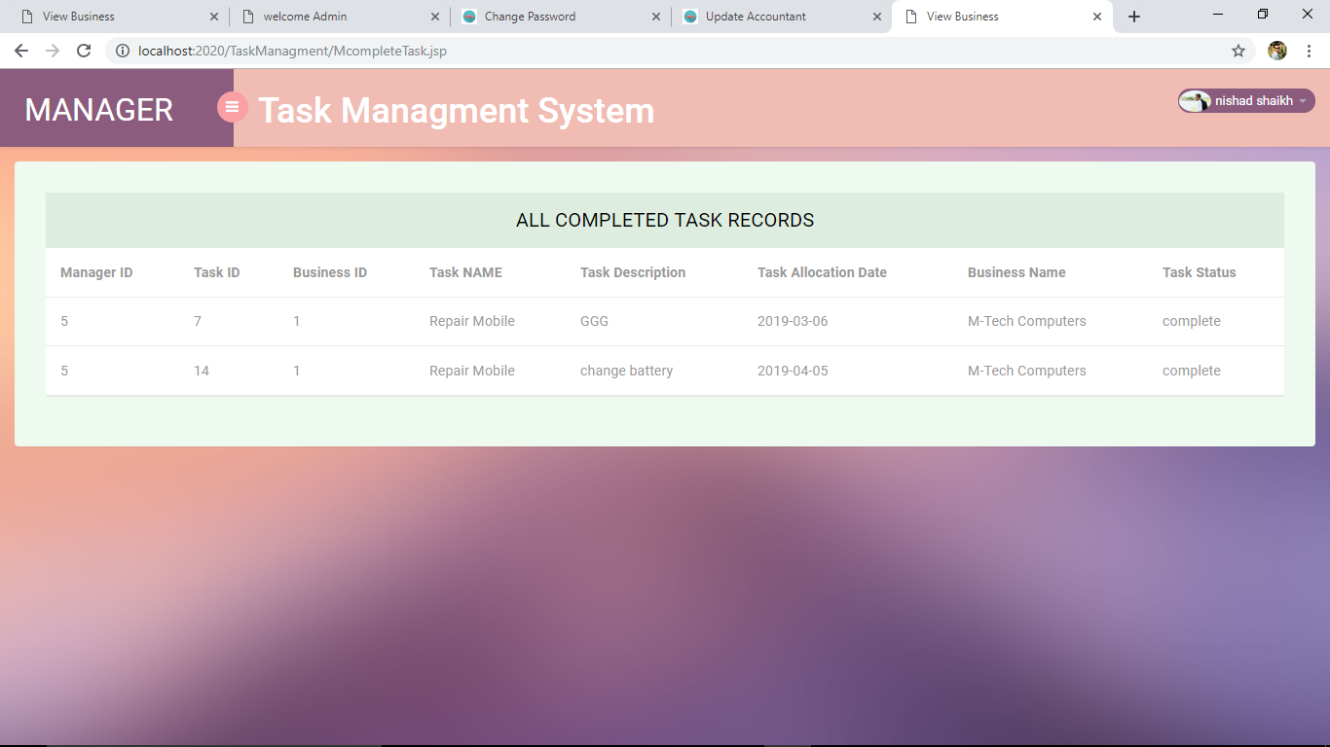

**14.Add New Employee:**

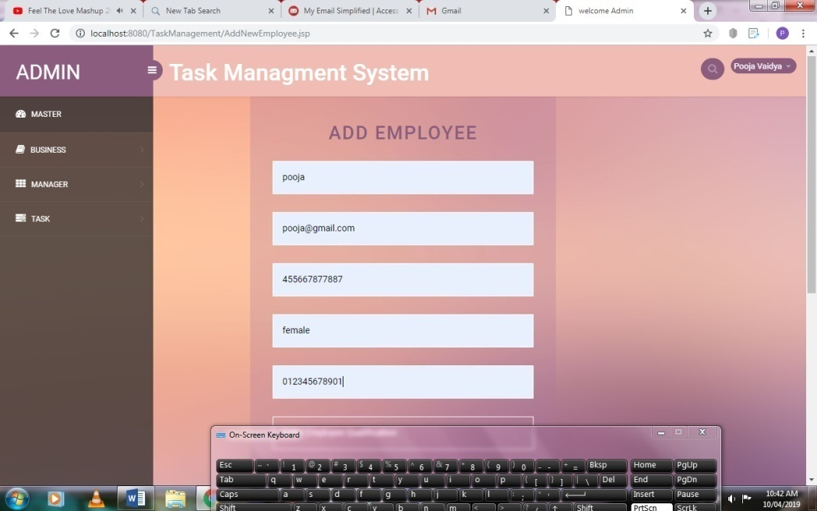

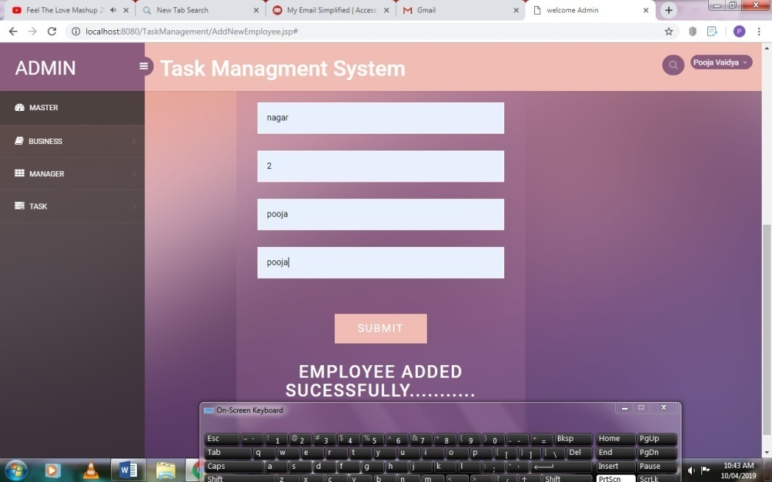

**4.10 Test Procedures and Implementation**

**1] Test case For Admin Login Page:**

Project Name: Task Management System

Project Code: TMS

Total no of test Cases:-04

Total no of test Cases Passed:-04

Total no of test Cases failed:-00

Total no of test Cases executed:-04

Total no of test Cases pending:-00

|  |  |  |  |  |  |
| --- | --- | --- | --- | --- | --- |
| **Test Case ID** | **Test Case Procedure** | **Input**  **Data** | **Expected**  **Output** | **Actual Output** | **Test**  **Status** |
| FCRM-LG-01 | Checking the functionality of Admin LOGIN Button | 1.Enter valid Usernames in textbox  2. Enter valid Password in textbox  3. Click on Admin LOGIN Button | Admin Welcome page should be displayed | Admin Welcome page displayed | Pass |
| FCRM -LG-02 | Checking the functionality of Admin LOGIN Button | 1.Enter invalid User Name in text box  2. Enter valid Password in password textbox  3. Click on Admin LOGIN Button | Admin Welcome page should not be displayed | Admin Welcome page is not displayed | Pass |
| FCRM -LG-03 | Checking the functionality of Admin LOGIN Button | 1.Enter valid User name in User name textbox  2. Enter invalid Password in password textbox  3. Click on Admin LOGIN Button | Admin Welcome page should not be displayed | Admin Welcome page is not displayed | Pass |

|  |  |  |  |  |  |
| --- | --- | --- | --- | --- | --- |
| FCRM -LG-04 | Checking the functionality of Admin LOGIN Button | 1.Enter invalid User name in User name textbox  2. Enter invalid Password in password textbox  3. Click on Admin LOGIN Button | Admin Welcome page should not be displayed | Admin Welcome page is not displayed | Pass |

**CHAPTER: 5 USER MANUAL**

**5.1 LOGIN**

5.1.1 DESCRIPTION & PRIORITY

This feature will be used to LOG IN only permitted users can use the Employee Payroll System. It is done in order to prevent any misuse of the system.

5.1.2 STIMULUS / RESPONSE SEQUENCES

When the user gives the correct username and password, he/she is transferred to the main screen or the main page.

5.1.3 FUNCTIONAL REQUIREMENTS

Purpose to check the credibility of a user and to prevent any misuse of the product The user will be transferred to the main page on successful validation and will be alerted if the validation is unsuccessful

**5.2 NEW USER REGISTRATION**

5.2.1 DESCRIPTION & PRIORITY

Its purpose is to create a new account for Employee or Manager or Admin. A user must be registered before he/she wants to use the system.

5.2.2 STIMULUS / RESPONSE SEQUENCES

On successful validation of each data field (user details), the registration takes placeand the success message is displayed.

5.2.3 FUNCTIONAL REQUIREMENTS

Purpose to register a new useris to use the system and to get username and password to make login into the system.

**6 .Drawback and Limitation**

Although we have tried our level best to make this system effective and efficient, there are some limitations, which we have realized. The system has following limitations and constraints.

* System is not totally automated some manual processing is required.
* Limited number of scenarios covered.
* System requires an internet connection.
* User should have basic knowledge of how to use internet.

**7 .Future Enhancement**

The proposed enhancements of this system are as follows:

* We are trying to make system easier to use.
* We are trying to make system as small as it would be accessed on mobile also.
* We are trying to make available the Service Provider information in more details.
* We are trying to make a payment of Customer for service .
* . Integrate Payment Gateway Options.
  1. **Conclusion**

During development of this system we learned new technologies, which would serve us in future. We have tried our level best to develop a system according to user requirement.

Although during development we did come across many problems both technical and conceptual. But we solved all those during development period. Also we can’t ignore the drawbacks and limitations of our system and in future we will make the enhancement on the system.

Altogether it was a great experience, and we have learned a lot during system development. Working on this project we got exposed to realistic approach of designing and could learn various strategies of hedging risks and also improvise our development skills. During the process of development.

**9. BIBLIOGRAPHY**

**Books:-**

For the reference purpose, following books were referred:

* **Head First-** By Bert Bates and Kathy Sierra
* **SCJP-** By Kathy Sierra
* **Google**

**Web References: -**

* [www.google.com](http://www.google.com/)
* [www.javatutorials.com](http://www.javatutorials.com/)
* [www.wikipedia.com](http://www.wikipedia.com/)
* [www.javatpoint.com](http://www.javatpoint.com/)
* [www.docs.oracle.com](http://www.docs.oracle.com/)
* [www.w3school.com](http://www.w3school.com/)
* [www.mkyong.com](http://www.mkyong.com)

**10. ANNEXURE**

**ANNEXURE :1 INPUT USER INTERFACE:**

**ADMIN LOGIN:**